Executive Summary:

This project focuses on the design and performance evaluation of a centrifugal pump system intended for efficient fluid transfer in industrial applications. The system was tested under varying flow and head conditions to determine its operational characteristics and overall efficiency. It does this by spinning an impeller that forces fluid from the inlet towards the outlet, creating a pressure differential to move fluid.
The pump achieved a maximum head of 1.95 meters and a peak flow rate of 1.24 liters per minute. Electrical measurements during testing indicated a typical operating voltage of 12 V and a current draw of 0.29 A. Performance analysis revealed a peak efficiency of 4.9%, which occurred at a head of 1.76 meters.
Overall, these results indicate that the centrifugal pump operates effectively within its intended design specifications, providing a reliable and energy-efficient solution for applications requiring medium to high pumping capacity.

Assembly and Exploded Parts
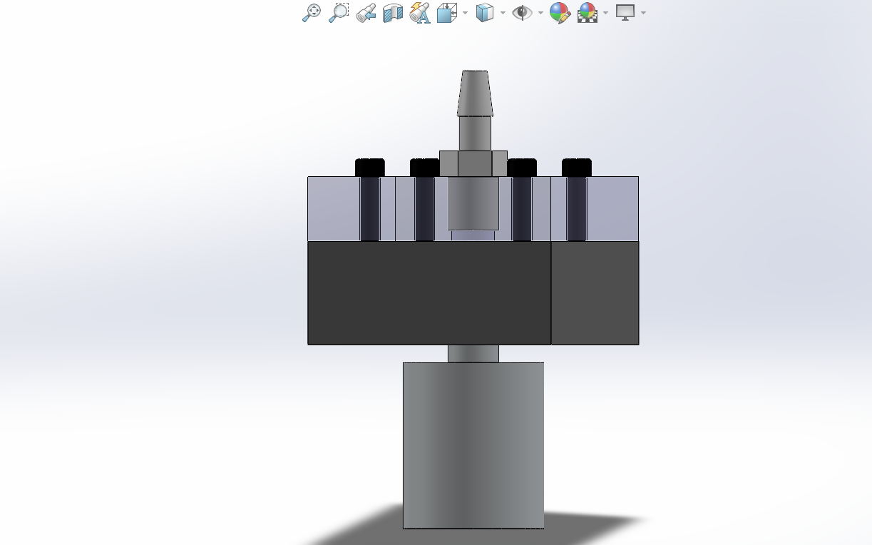
Figure 1 – Assembly View of Pump Figure 2 - Exploded View of Pump
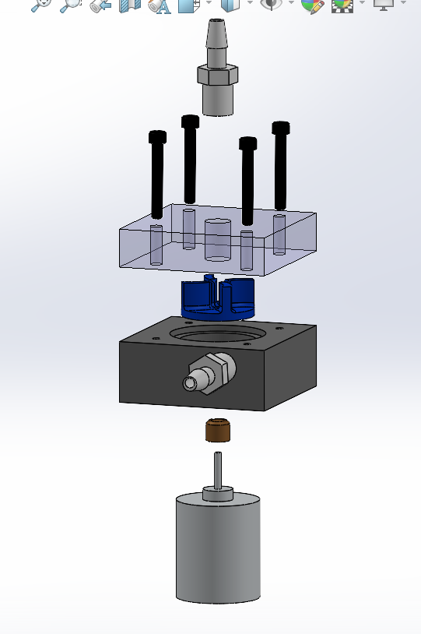

Main Component Description:

The assembly (figure 1) and configuration of the pump system were documented using visual aids through Solidworks.It shows the internal structure of the pump and how each part of the pump functions with an assembly and exploded view.
Starting from top- down of the (figure 2) exploded view,
The Pump Inlet is a suction port that leads to the water in the pump body so it can be moved mechanically by the impeller. The Screws secure the face plate assembly and the pump body assembly together. The Faceplate provides stability of the pump assembly by enclosing the impeller. The Impeller is a rotation component that provides kinetic energy to the fluid(water). The Pump Body encloses the impeller and directs water flow from the inlet to the outlet. The Pump Outlet allows the water to exit the pump body after being pressurized into the water column. Bronze Bushing is a small component inserted into the pump body to provide a bearing surface for the pump body and minimize leakage. The Motor provides torque for the impeller’s rotation.

Final Pump and Testing Process
The completed pump and the procedures used to test its performance were captured in several views:
Figure 3 – Side View of Final Pump Figure 4 – Front View of Final Pump
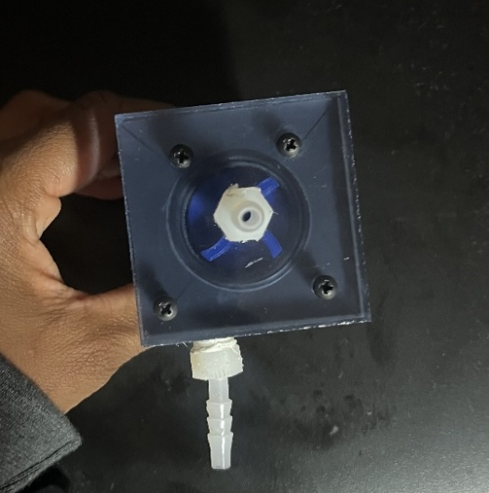
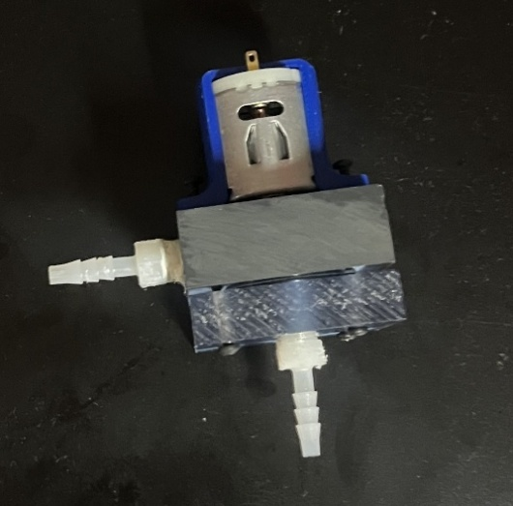
Figure 5 – Pump Testing Procedure
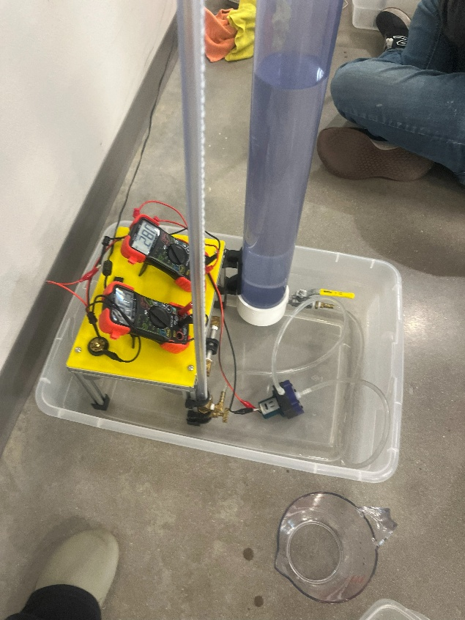
Equipment Used :
DC Power Supply (12V): Provided electrical power to the motor during test
Multimeters: One multimeter to measure current and the other to measure voltage
Extra bucket to pour extra water back into the water tank.
Switch: For DC Power to Pump
Vinyl Tubing: allows the flow of water from the water tank to the pump inlet and from the pump outlet to the water column
Pump Ports: Allows the water flow into the pump to be pressuireed mechanically and allows exit of the pump.
Valve on Water Tank: To allow/stop water flow through pump
Valve on Water Column: To adjust flow rate/pump head
Water Exit: To allow to pour into water measuring cup
Stopwatch: Timed each trial to determine an flow rate over 20 seconds
Measuring Cup: water collection bucket to measure in mL
This setup allowed consistent and accurate data collection across 6 trials

Raw Data and Computed Values
The following table presents the raw data collected during pump testing across multiple trials, detailing the height of water above the reservoir, electrical current, voltage, duration of water collection, and the corresponding volume of water collected over 20 seconds.
Table 1 - Raw Data
Trial | Height of water above reservoir (cm) | Electrical Current (A) | Voltage across pump leads (V) | Length of time that water is collected (s) | Volume of water collected over 20 seconds (mL)
Height 1 | 195 | 0.27 | 12 | 20 | 0
Height 2 | 176 | 0.28 | 12 | 20 | 193
Height 3 | 111 | 0.28 | 12 | 20 | 292
Height 4 | 60 | 0.30 | 12 | 20 | 353
Height 5 | 50 | 0.29 | 12 | 20 | 356
Height 6 | 20 | 0.29 | 12 | 20 | 413

Since the raw data was not in the si Unit I could not properly analyze the data propeprly however. The 20 seconds staying the same throughout the testing procedure is an sign of controlled conditions which leads to accurate and consistent data. While the the current and voltage staying reading the same throughout the whole process recognize says that the pump head doesnn’t head doesn’t affect the voltage and current and recognize the circuit as an series.

Computed Pump Performance Values
The following table presents the computed values for pump performance under varying conditions. The parameters measured include Volume of Water (L), Pump Head (m), Weight (N), Velocity (m/s), Pump Efficiency (%), and Flow Rate (L/min). Each data point corresponds to a different set of operating conditions for the pump.
Weight(N) | Velocity (m/s) | Pump Efficiency (%) | Flow Rate (L/min)
0 | 0 | 0 | 0
1.89333 | 0.431844625 | 4.985501583 | 0.579
2.86452 | 0.65336078 | 4.824318043 | 0.876
3.46293 | 0.789850533 | 3.038708294 | 1.059
3.49236 | 0.796563143 | 2.671154146 | 1.068
4.05153 | 0.924102748 | 1.417600511 | 1.239

Since the computed values was recorded as shown in the table, The table displays corresponding inverse relationship between the pump head and the weight, velocity and flow rate as the pump head decreases the relationship with the weight, velocity and the flow rate increases. There is a positive relationship between the pump head and the pump efficiency because as the pump head decreases the pump’s efficiency decreases. This data is essential for analyzing pump performance and optimizing its operation.

Handwritten Calculation of Velocity, Flow Rate and Pump Efficiency
Figure 6- Handwritten Calculation (Single Data Point)
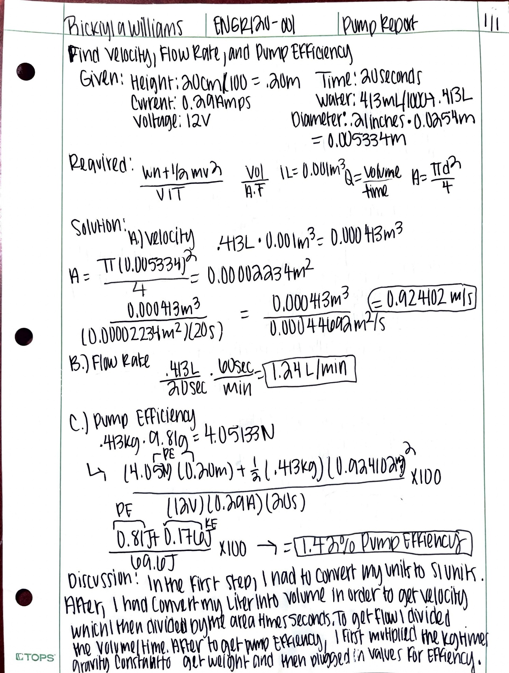
The analysis includes a detailed handwritten calculation for a single data point, which illustrates the process of determining velocity, flow rate, and pump efficiency. The calculations provide a clear example of how these variables are derived and their significance in evaluating pump performance which is included in the discussion.

Data Plot of Flow vs. Pump Head
The following figure shows the relationship between pump head and flow rate. This data plot is provides visual aid in how changes in Pump Head affect the flow rate.
Figure 7- Pump Head vs. Flow Rate

The plot demonstrates that as the Pump Head(M) increases, the flow rate decreases which is a characteristic of the centrifugal pump performance, displaying and inverse relationship. A best-fit polynomial trendline was added because it was the trendlines r2 value that was closet to 1. Additionally, both the trendline equation and r2 value are displayed as evidence and for analysis for linear regression.

Data Plot of Pump Efficiency(%) vs. Pump Head (m)
The next following Data presents the relationship between pump head(m) and pump efficiency(%). This data plot is significant for visualizing how changes in pump head impact the pump effiency.
Figure 8 - Relationship between Pump Efficiency (%) vs. Pump Head(m)

The plot demonstrates a positive correlation between the pump Head(m) and Pump Efficiency since as the pump head increased the pump efficiency also increased. The plot also highlights how efficiency varies with head, show a peak near 1.76 meters. Another polynomial trendline was added to the plot due to its high r2 value compared to other trendlines. The r2 and trendline equation are displayed on the plot for analysis.

Conclusion:
The centrifugal pump system was successfully designed, assembled, and tested to determine its pump performance and efficiency. Experimental results indicated a maximum head of 1.95 meters, peak flow rate of 1.24 L/min, and maximum efficiency of 4.9% at a head of 1.76 meters.
The use of SolidWorks modeling allowed for precise visualization of assembly and component interactions, confirming mechanical alignment and manufacturability. Testing equipment such as the Water column, Valves, DC power supply, and multimeters ensured accurate measurement of pump performance.
The relationship between head, flow rate, and efficiency followed the expected behavior of a centrifugal pump. An increase in the pump head corresponded to a decrease in flow rate, while overall pump efficiency improved under higher conditions. This trend is influenced by the valve’s shutoff tightness during operation. When the valve exhibits high shutoff tightness, the pump head increases, and the efficiency is increased due to improved control of the water flow via valve. However, when the valve is fully open, the pump head decreases sharply, and the flow rate increases due to deregulation of water flow. Ultimately, resulting in reduced pump performance.
Overall, the project demonstrates sharplysibility of the centrifugal pump design and provides a foundation for improving impeller geometry, minimizing losses, and enhancing efficiency in future iterations.
%

